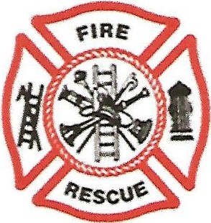

GREATER MOMENCE FIRE PROTECTION DISTRICT
15 N. PINE STREET MOMENCE, IL 60954
Chief: James Spoon Trustees: David Horn Jordan Lee
Joey Baud

BOARD OF TRUSTEES SPECIAL MEETING MINUTES

DATE: NOVEMBER 29TH, 2022

CALLED TO ORDER AT 3:30 P.M. WITH THE PLEDGE OF ALLEGIENCE

ROLL CALL: JOEY BAUD- PRESENT, JORDAN LEE- PRESENT, DAVID HORN-PRESENT

GENERAL PUBLIC: MYRON MUNYON, ZANE METZ, MIKE HESS, MIKE MITHCELL,
ZACK KRENKEL

NO MINUTES OR OTHER REPORTS WERE GIVEN; THE ONLY BUSINESS WAS TO REVIEW AND VOTE ON THE INSURANCE PROPOSAL.

DAVE HORN MADE A MOTION TO APPROVE THE REVIEWED INSURANCE PROPOSALS
WHICH WAS 2ND BY JORDAN LEE. ROLL CALL VOTE- DAVE HORN YES,
JORDAN LEE- YES, JOEY BAUD- YES.

A MOTION TO CLOSE THE MEETING WAS MADE BY DAVE HORN, 2ND BY JORDAN LEE.
ROLL CALL VOTE: DAVE HORN- YES, JORDAN LEE-YES, JOEY BAUD- YES

MEETING ADJOURNED: 4:28 P.M.

MEETING RECORDED BY JOEY BAUD- SECRETARY

